SOFTWARE REQUIREMENTS SPECIFICATION FOR RESTAURANT ORDER MANAGEMENT SYSTEM

UMINOO HIKARI RESTAURANT MANAGEMENT SYSTEM
Version: 1.2 Date: 04/01/2026

Document Revision History
Date | Version | Description of Changes | Author
27/12/2025 | 1.0 | Initial Draft | Group 12
30/12/2025 | 1.1 | Added System Diagrams | Group 12
04/01/2026 | 1.2 | Updated UI Design | Group 12

Contents
1. INTRODUCTION 5
1.1. Purpose 5
1.2. System Scope 5
1.3. User Classes and Characteristics 6
2. OVERALL SYSTEM DESCRIPTION 7
2.2. User Groups & Permissions 7
3. DESIGN CONSTRAINTS 8
3.1. Technology Stack 8
3.2. Hardware Requirements 8
3.3. Network Constraints 8
3.4. Other Constraints (Business Rules) 8
4. FUNCTIONAL REQUIREMENTS 8
4.1. Online Reservation 8
4.2. Ordering at the Table 9
4.3. Payment and Billing 9
4.4. System Administration 9
5. NON-FUNCTIONAL REQUIREMENTS 10
5.1. Performance 10
5.2. Availability & Reliability 10
5.3. Security 10
5.4. Data Integrity & Data Safety 11
5.5. Usability 11
5.6. Maintainability 11
5.7. Scalability 11
5.8. Compliance 11
6. DATA FLOW DIAGRAM (DFD) 12
7. USE-CASE DIAGRAM 18
8. CLASS DIAGRAM 32
9. DATABASE SCHEMA 32
10. USER INTERFACE DESIGN 34
10.1. Visitor – Online Table Reservation Interface 34
10.2. Customer / Staff – Table Ordering Interface (Mobile) 35
10.3. Staff – Login & Table List Interface 36
10.4. Interface Admin – Login 36
10.5. Admin – Cashier (POS) Interface 37
10.6. Staff Management Interface 40
10.6. Menu Management Interface 41
10.7. Dashboard Interface 42
11. APPENDIX 11.1. Glossary 43
11.2. References 43

1. INTRODUCTION

1.1. Purpose
This document specifies the requirements for the Uminoo Hikari Restaurant Management System, covering functional requirements, non-functional requirements, Data Flow Diagrams (DFD), Use Case Diagrams, Class Diagrams, Data Models, and User Interface Design.
This document serves as the basis for:
- System Analysis and Design
- Software Development
- Testing (Quality Assurance)
- Operation and Maintenance
The system is designed to facilitate restaurant operations, including food ordering, billing, table management, inventory management, and staff management.

1.2. System Scope
The system supports the operations of Uminoo Hikari Japanese Restaurant with the following main functions:
- Visitor: Online table reservation.
- Customer: QR code scanning for table-side ordering.
- Staff: Order assistance.
- Admin: Cashier (payment processing), menu management, staff management, and revenue reporting.
Out of Scope (Exclusions)
The system explicitly excludes the following features:
- Inventory / Raw Material Management.
- Table Merging / Splitting.
- Bill Merging / Table Transfer.
- Order modification after submission.
- Invoice modification after payment.
- Staff Payroll Management.
- Membership Loyalty Program.
System Interfaces
The Uminoo Hikari system is a Japanese restaurant management application that supports the following interfaces:
- Visitor Interface: Allows users to view restaurant information and make online reservations.
- Customer Interface: Allows customers to view the menu and place orders at the table.
- Staff Interface: Allows staff to view the menu, place orders for customers, and manage tables.
- Admin Interface: Allows administrators to view the dashboard (overview), manage menus, place orders, process payments (cashier), and manage tables, products, and staff.

1.3. User Classes and Characteristics
- Visitor: Web visitors who access the restaurant's website to make online table reservations.
- Customer: Dine-in guests who place orders at the table (by scanning QR codes).
- Staff: Service staff responsible for handling orders (a distinct role, unauthorized to process payments).
- Admin: Performs cashier duties (payment processing), administers the entire system, and monitors operations.
1.4. Definitions and Acronyms
- SRS: Software Requirements Specification.
- UI: User Interface.
- CRUD: Create, Read, Update, Delete (Basic database operations).
- POS: Point of Sale.
- Staff: Table service employees (restricted to order processing only, excluding payment duties).
- Admin: Restaurant Manager – also assumes the Cashier role and holds full system privileges.
- QR Code: Table identifier code used by customers to scan and place orders.
- COD: Cash on Delivery (Cash payment).
- Capacity-based Booking: A reservation method based on total restaurant capacity, where specific tables are not assigned at the time of booking.

2. OVERALL SYSTEM DESCRIPTION
2.1. System Architecture
The Uminoo Hikari system follows a Client-Server architecture consisting of the following key components:
- Frontend: User Interface (supporting Mobile/Tablet/Desktop).
  - Optimized for Mobile: For Visitor, Customer, and Staff interfaces.
  - Optimized for Tablet/iPad/Laptop: For the Admin interface.
- Backend: Server responsible for processing business logic.
- Database: Database for data storage and retrieval.

2.2. User Groups & Permissions
Authentication and Authorization management (ensuring a clear separation between Staff and Admin roles).
User Role | Primary Permissions
Visitor | Make Online Reservation.
Customer | View Menu, Place Order (Create Order), Request Bill.
Staff | Place Order on behalf of customer, View Table Map.
Admin | Process Payment, Manage Menu, Manage Staff, View Reports, Manage Tables, Manage Products.

2.3. Assumptions and Dependencies
- Unique Identifiers: Each table is assigned a unique QR code.
- Device Availability: Users have access to mobile devices or computers to interact with the system.
- Network Connectivity: The restaurant maintains a stable internet connection.
- Financial Security: The Admin has exclusive authority to process financial transactions (finalize orders).

3. DESIGN CONSTRAINTS

3.1. Technology Stack
- Backend: Python Django Framework.
- Frontend: ReactJS + CSS.
- Database: MySQL 8.0.

3.2. Hardware Requirements
- Customer / Staff: Smartphones (Android/iOS) running Android 8.0 or later (Optimized for mobile view).
- Admin: Tablets (iPad or Android tablet) or Laptops/PCs (Windows 10+, macOS 10.14+).

3.3. Network Constraints
- Bandwidth: Requires a stable Internet connection with a minimum speed of 50 Mbps.
- Synchronization: Automatic data synchronization upon connectivity.

3.4. Other Constraints (Business Rules)
- Payment Authority: Only the Admin role is authorized to process payments.
- Order Immutability: Submitted orders cannot be modified.
- Order Cancellation: The Admin has the authority to delete entire unpaid orders.
- Table Status: Upon payment completion, the table status shall automatically revert to "Available".
- Availability: The system shall operate continuously (High Availability).

4. FUNCTIONAL REQUIREMENTS
The Uminoo Hikari Japanese Restaurant requires the development of an operations management system comprising the following key functional groups:

4.1. Online Reservation
- The system shall allow Visitors to submit remote reservation requests by providing the following details: Full Name, Phone Number, Party Size (Number of Guests), and Estimated Arrival Time.
- The system shall capture reservation data and display a list of requests for the Admin to review and manage.

4.2. Ordering at the Table
- Access: Upon scanning the unique QR code at the table, the system shall grant access to Customers, or allow Staff members to place orders on behalf of customers.
- Menu Display: The system shall display a detailed menu, including item names, prices, images, and categories. Users can select items, adjust quantities, and add notes (e.g., dietary preferences).
- Order Submission & Locking:
  - Once an order is submitted, the system shall update the table status to "Occupied".
  - The submitted order shall be locked (immutable); individual items cannot be edited or removed to ensure synchronization with kitchen operations.
  - Users may Request Bill (Request Payment) after finishing their meal.

4.3. Payment and Billing
- Access Control: This function is exclusive to the Admin. The system shall allow the Admin to select a table and view the details of ordered items.
- Billing Adjustments: The Admin shall have the ability to apply discounts (%), add surcharges, and select the payment method (Cash or Bank Transfer).
- Completion & Reset: Upon payment completion, the system shall automatically:
  - Calculate the total amount.
  - Archive the invoice.
  - Record revenue.
  - Revert the table status to "Available".
- Order Cancellation: The Admin shall have the authority to delete entire unpaid orders (in cases of customer cancellation or entry errors).

4.4. System Administration
- Menu Management: The Admin can add, update, or delete food items and menu categories.
- Staff Management: The Admin has full authority to create, modify, and remove staff account information.
- Statistical Reporting: The system shall generate detailed revenue reports:
  - Filtered by timeframes: Today, Week, Month, Quarter, Year.
  - Categorized by: Payment methods.

5. NON-FUNCTIONAL REQUIREMENTS

5.1. Performance
- NFR-01.1 – Response time:
  - The system shall process and return results within three (03) seconds for ordering, viewing the menu, and selecting tables.
  - For payment processing and revenue statistics, the response time shall not exceed five (05) seconds.
- NFR-01.2 – Concurrent user support:
  - The system shall support at least thirty (30) tables operating concurrently.
  - The system shall allow at least fifty (50) users to access the system at the same time.
- NFR-01.3 – Order processing capability:
  - Orders shall not be lost or duplicated.
  - When a user selects “Submit Order,” the system shall ensure that the order is recorded exactly once.
- NFR-01.4 – Data loading:
  - Food item images shall be loaded within two (02) seconds.

5.2. Availability & Reliability
- NFR-02.1 – System uptime: The system availability shall be at least 99% during the restaurant’s operating hours.
- NFR-02.2 – Fault tolerance and self-recovery: In the event of Internet connection loss, previously stored data shall not be lost. Once the connection is restored, the system shall automatically synchronize data.
- NFR-02.3 – System startup time: The system startup time shall not exceed two (02) minutes.

5.3. Security
- NFR-03.1 – User authorization: Each user role is permitted to perform only its designated functions (Visitor, Customer, Staff, Admin).
- NFR-03.2 – Authentication security: Admin and Staff accounts are required to log in using assigned credentials.
- NFR-03.3 – Revenue protection: Invoices cannot be modified after payment. Submitted orders cannot be edited.
- NFR-03.4 – Unauthorized access prevention: Access to internal system functions shall be restricted to authenticated users only.
- NFR-03.5 – Data backup: System data shall be automatically backed up daily at 2:00 AM.

5.4. Data Integrity & Data Safety
- NFR-04.1 – Data loss prevention: Stored data shall not be lost or incorrectly overwritten after being saved.
- NFR-04.2 – Order immutability rule: Once an order is submitted, it shall not be modified.
- NFR-04.3 – Data consistency: The displayed total amount shall be consistent with the invoice total and the recorded revenue.

5.5. Usability
- NFR-05.1 – Number of operational steps: The ordering process requires no more than three (03) steps. The payment process requires no more than four (04) steps.
- NFR-05.2 – Intuitive user interface: The interface uses a harmonious color scheme with a logical layout. Table status colors are applied consistently (White: Available, Green: Occupied).
- NFR-05.3 – User friendliness: First-time users are able to complete an order within five (05) minutes.

5.6. Maintainability
- The system includes user manuals and technical documentation.
- The source code is clearly structured, readable, and facilitates future maintenance and feature enhancements.

5.7. Scalability
- The system supports adding new tables and increasing the number of users without requiring changes to the core system architecture.

5.8. Compliance
- The system complies with standard UI/UX guidelines and personal data protection regulations.

6. DATA FLOW DIAGRAM (DFD)

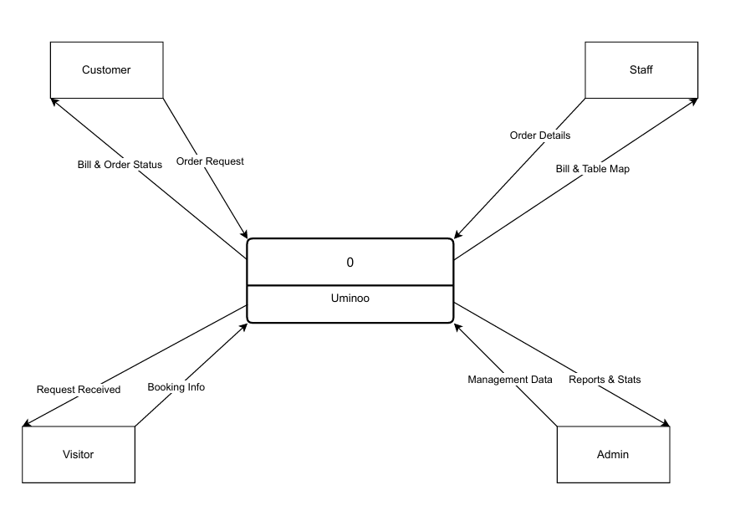

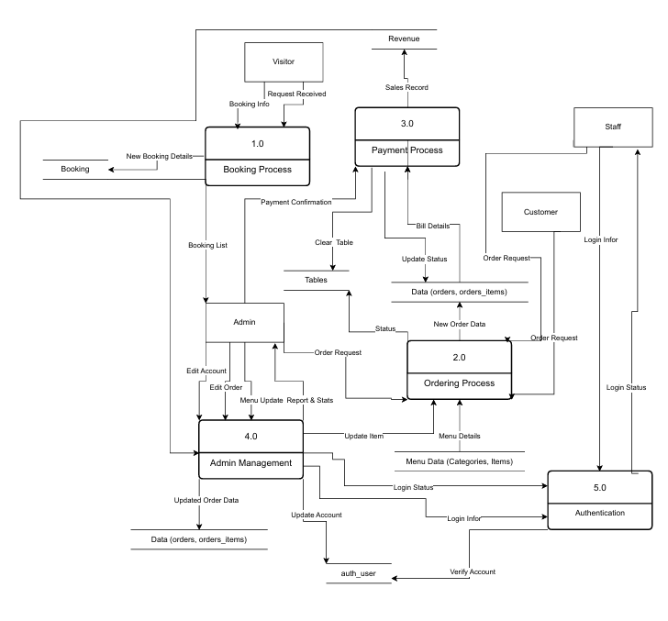

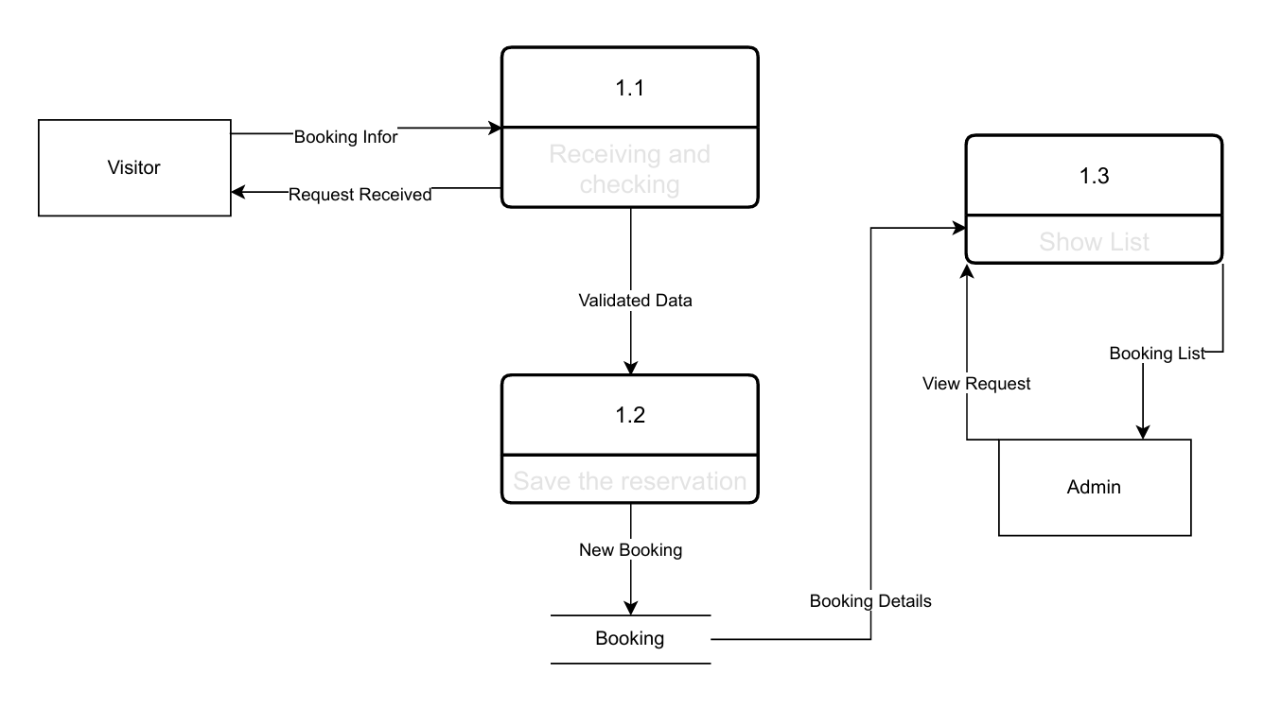

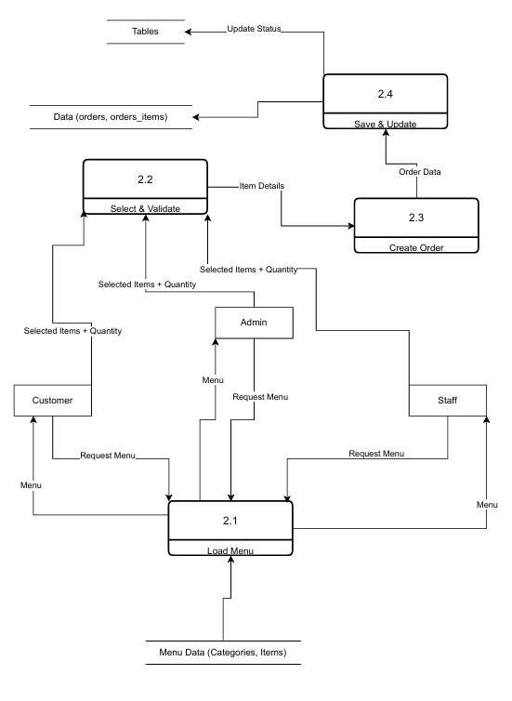

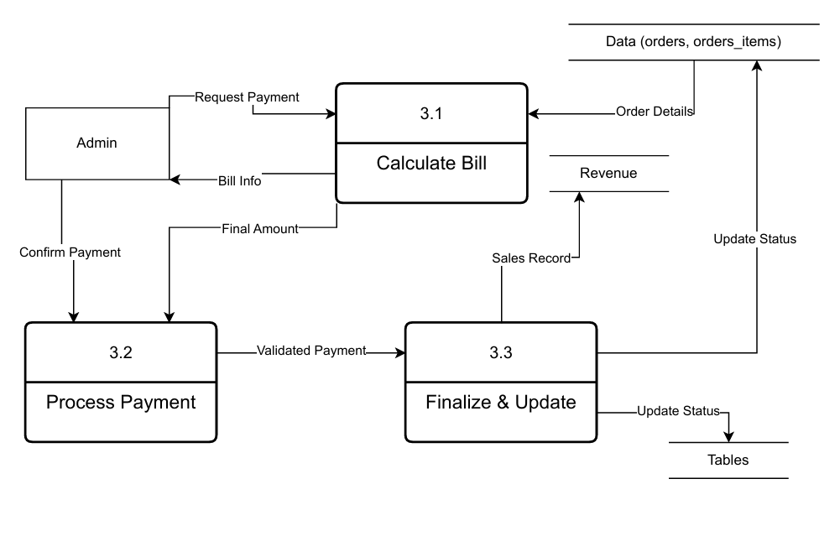

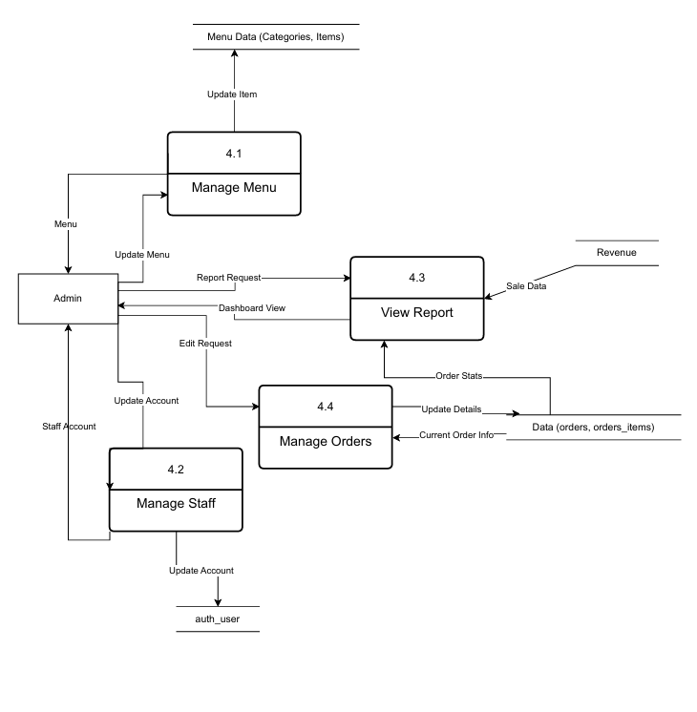

7. USE-CASE DIAGRAM
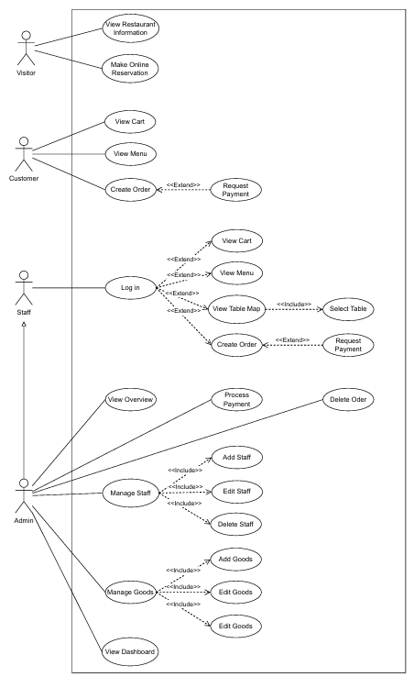

USE CASE SPECIFICATION
Restaurant Management System

UC-001 — View Restaurant Information
Description:
The visitor views general information about the restaurant.
Actor:
Visitor
Preconditions:
The website URL is available
The website is operating normally
Postconditions:
Restaurant information is displayed successfully
Main Flow:
The visitor accesses the website
The system displays restaurant information

UC-002 — Make Online Reservation
Description:
The visitor makes a table reservation via the website.
Actor:
Visitor
Preconditions:
The website is operating normally
Postconditions:
Reservation information is sent to the admin
Main Flow:
The visitor selects Make a Reservation
The visitor enters name, phone number, number of guests, and time
The visitor clicks Confirm
The system saves the data and notifies the admin
Alternative Flows:
Missing information → display error message
Data saving error → display failure notification

UC-003 — View Menu
Description:
Users view the list of dishes categorized by type.
Actors:
Customer, Staff, Admin
Preconditions:
Customer has scanned the QR code
Staff/Admin has logged in
Postconditions:
Menu is displayed
Main Flow:
The user opens the menu
The system displays food categories and items

UC-004 — View Cart
Description:
Users view the selected dishes in the cart.
Actors:
Customer, Staff, Admin
Preconditions:
The user is in the table interface
Postconditions:
Cart information is displayed
Main Flow:
The user opens the cart
The system displays selected items and total price

UC-005 — Create Order
Description:
The selected menu items are sent to the restaurant as an order.
Actors:
Customer, Staff, Admin
Preconditions:
At least one item is selected
Postconditions:
Order is saved
Table status changes to Serving
Main Flow:
The user opens the menu
The user selects dishes
The user opens the cart
The user reviews selected items
The user clicks Submit Order
The system saves the order and displays success notification
Alternative Flow:
Empty cart → order cannot be submitted

UC-006 — Request Payment
Description:
The user requests payment for the table.
Actors:
Customer, Staff, Admin
Preconditions:
An order exists
Postconditions:
Payment request is sent to the admin
Main Flow:
The user clicks Request Payment
The system records the request
The admin receives a notification
Alternative Flow:
No order exists → request is rejected

UC-007 — Login
Description:
Staff or Admin logs into the system.
Actors:
Staff, Admin
Preconditions:
A valid account exists
Postconditions:
Login is successful
Main Flow:
User enters username and password
The system verifies credentials
If valid, the system grants access
Alternative Flow:
Invalid credentials → login fails

UC-008 — View Table Map
Description:
Staff/Admin views the table layout and table status.
Actors:
Staff, Admin
Preconditions:
User is logged in
Postconditions:
Table map and status are displayed
Main Flow:
User selects Table Map
The system displays the table layout with details:
White color: Available table
Blue color: Occupied table
Table name (e.g., B.5)
Occupied time (e.g., “1h 30m”)
Temporary total amount (e.g., “200,000 VND”)

UC-009 — Select Table
Description:
Staff/Admin selects a table to start service.
Actors:
Staff, Admin
Preconditions:
User is logged in
Postconditions:
Table is selected and ready for processing
Main Flow:
User selects a table
The system displays table information and navigates to:
Staff: Order screen
Admin (Cashier): Order and payment screen
Alternative Flow:
Table is already occupied → display current order information

UC-010 — Process Payment
Description:
The admin processes customer payment.
Actors:
Staff, Admin
Preconditions:
The table has an existing order
Postconditions:
Payment is completed
Revenue is updated
Table status changes to Available
Main Flow:
Admin accesses the Cashier tab
Admin selects a table
The system displays order details
Admin clicks Payment
The system displays payment details:
Subtotal
Discount (optional)
Service charge (optional)
Total amount
Customer payment amount
Payment method (Cash / Other account)
Change (auto-calculated)
Admin confirms payment
The system updates table status and revenue
Alternative Flows:
Apply discount → system recalculates total
Add service charge → system recalculates total

UC-011 — Manage Staff
Description:
Admin manages staff accounts.
Actor:
Admin
Preconditions:
Admin is logged in
Postconditions:
Staff list is updated
Main Flow:
Admin opens Staff Management
Admin adds, edits, or deletes staff accounts

UC-012 — Add Staff
Description:
Admin adds a new staff member.
Actor:
Admin
Preconditions:
Admin is logged in
Postconditions:
New staff account is created
Main Flow:
Admin clicks Add Staff
System displays input form:
Full name
Username (phone/email)
Password
Confirm password
Admin enters required information
Admin clicks Add Staff
New staff appears in the list

UC-013 — Edit Staff
Description:
Admin edits staff information.
Actor:
Admin
Preconditions:
Admin is logged in
Staff member exists
Postconditions:
Staff information is updated
Main Flow:
Admin opens staff list
Admin selects a staff member
System displays edit form
Admin updates information
System saves changes and updates the list

UC-014 — Delete Staff
Description:
Admin deletes a staff account.
Actor:
Admin
Preconditions:
Staff member exists
Postconditions:
Staff account is permanently removed
Main Flow:
Admin selects a staff member
Admin clicks Delete
System displays confirmation popup
Admin confirms deletion
System updates the staff list

UC-015 — Manage Goods
Description:
Admin manages food items.
Actor:
Admin
Preconditions:
Admin is logged in
Postconditions:
Menu is updated
Main Flow:
Admin opens Goods Management
Admin adds, edits, or deletes food items

UC-016 — Add Goods
Description:
Admin adds a new food item.
Actor:
Admin
Preconditions:
Admin is logged in
Postconditions:
New item appears in the menu
Main Flow:
Admin clicks Add Goods
System displays input form:
Image upload
Item name
Category
Price
Admin fills in all fields
Admin clicks Add Goods
System validates data and saves to database
Alternative Flow:
Invalid data → error message is displayed

UC-017 — Edit Goods
Description:
Admin edits food item information.
Actor:
Admin
Preconditions:
Food item exists
Postconditions:
Item information is updated
Main Flow:
Admin selects an item
Admin clicks Update
System displays edit form
Admin updates information
System saves changes

UC-018 — Delete Goods
Description:
Admin deletes a food item.
Actor:
Admin
Preconditions:
Food item exists
Postconditions:
Item is removed from the menu
Main Flow:
Admin selects an item
Admin clicks Delete
System displays confirmation popup
Admin confirms deletion
System removes item from database

UC-019 — Delete Order
Description:
Admin deletes an order of a table.
Actor:
Admin
Preconditions:
Table has an order
Postconditions:
Order is deleted
Table status changes to Available
Main Flow:
Admin selects a table
Admin selects Delete Order
Admin confirms deletion
Alternative Flow:
Admin cancels the action

UC-020 — View Dashboard
Description:
Admin views overall restaurant statistics.
Actor:
Admin
Preconditions:
Admin is logged in
Postconditions:
Dashboard statistics are displayed
Main Flow:
Admin opens Dashboard
System displays:
Total revenue
Cash revenue
Other payment revenue
Total orders
Admin can filter by time (e.g., Yesterday)
System displays:
Online reservation list
Best-selling items

8. CLASS DIAGRAM

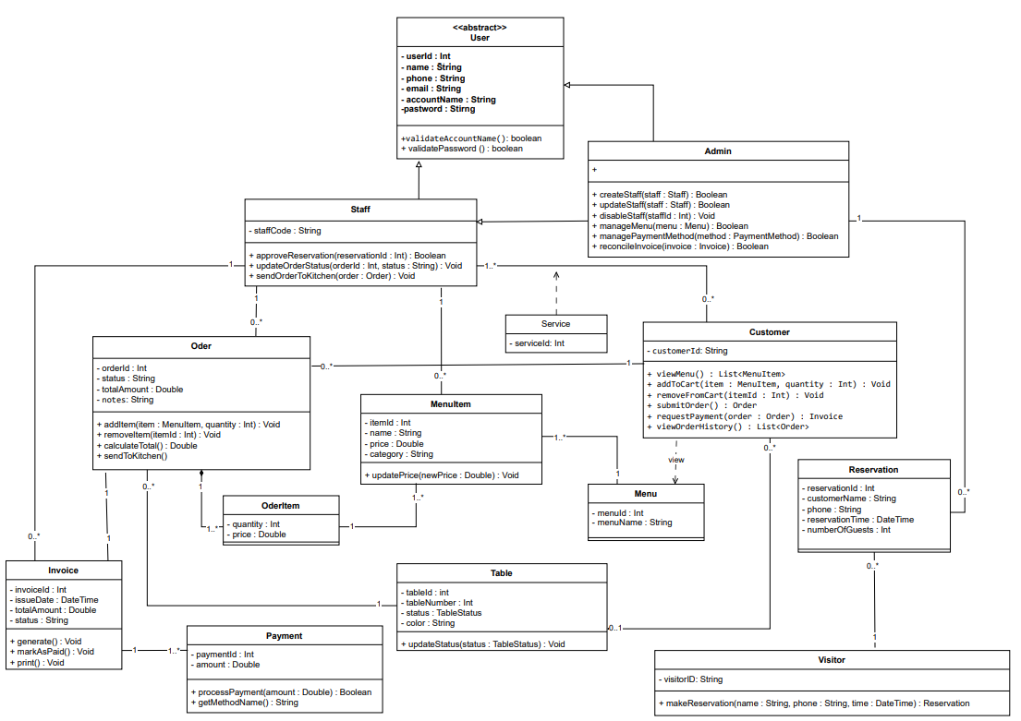

9. DATABASE SCHEMA

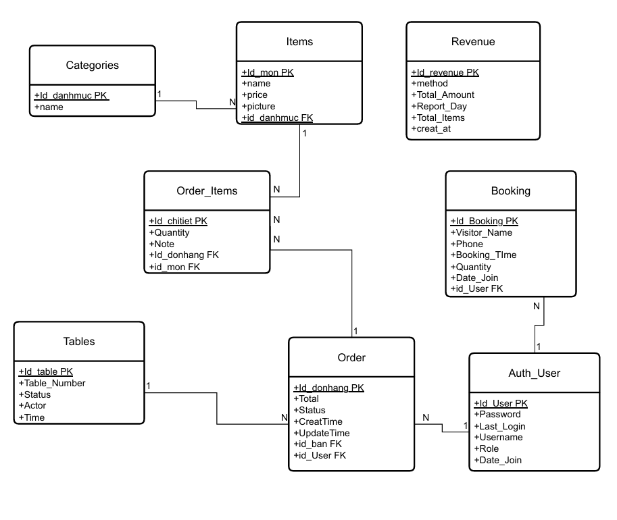

10. USER INTERFACE DESIGN

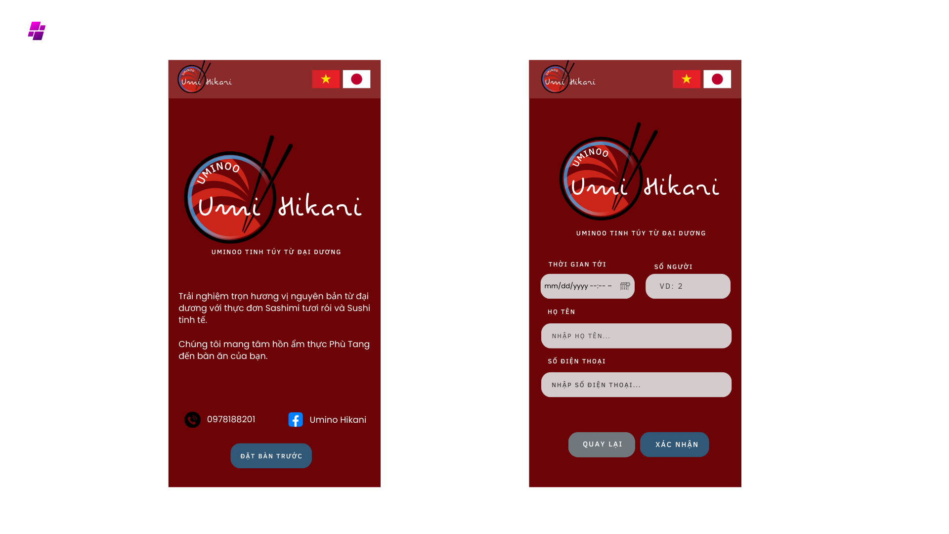
10.1. Visitor – Online Table Reservation Interface

10.2. Customer / Staff – Table Ordering Interface (Mobile)
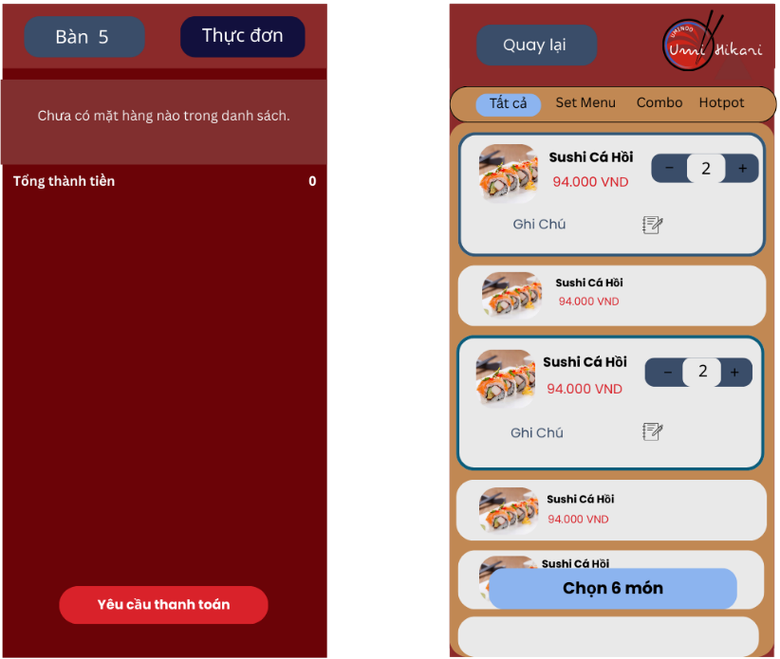
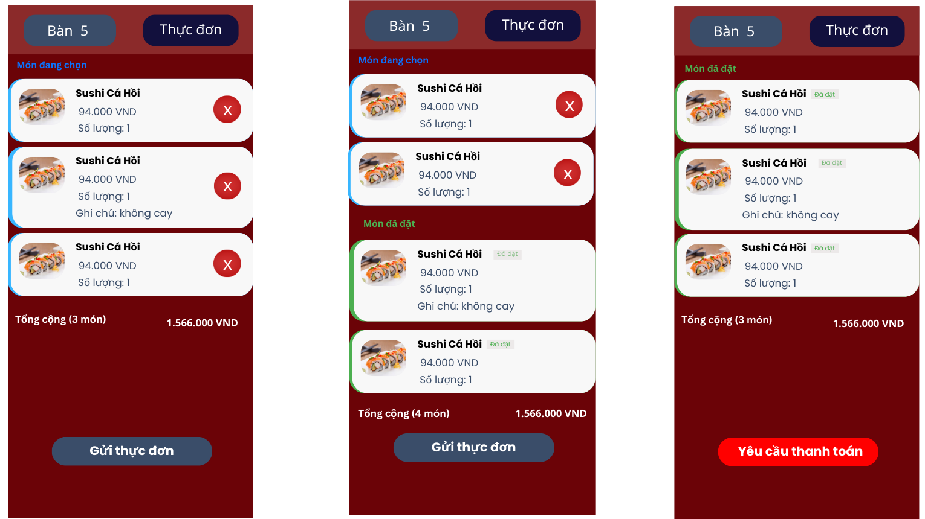

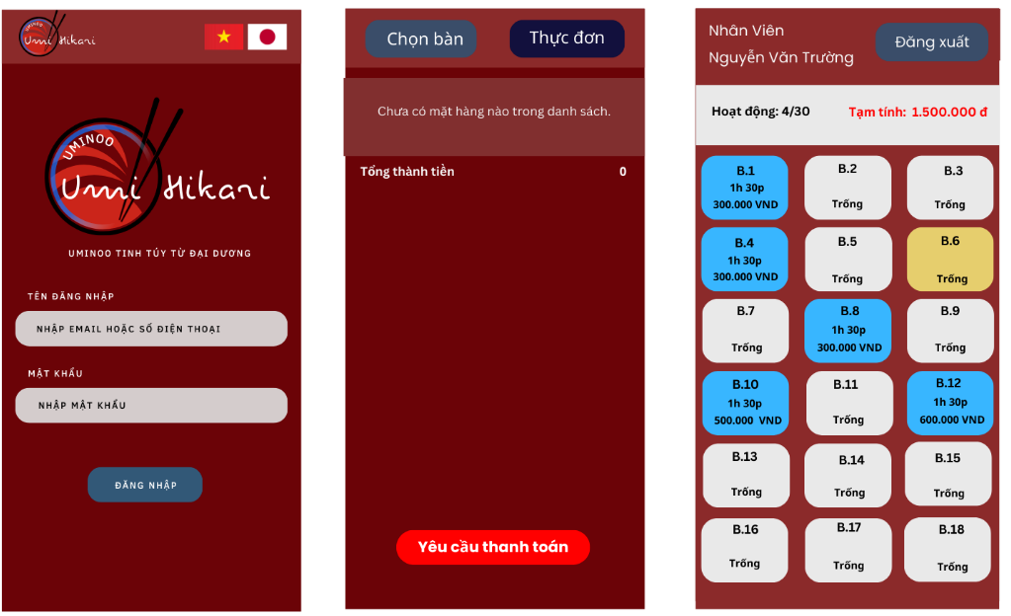
10.3. Staff – Login & Table List Interface

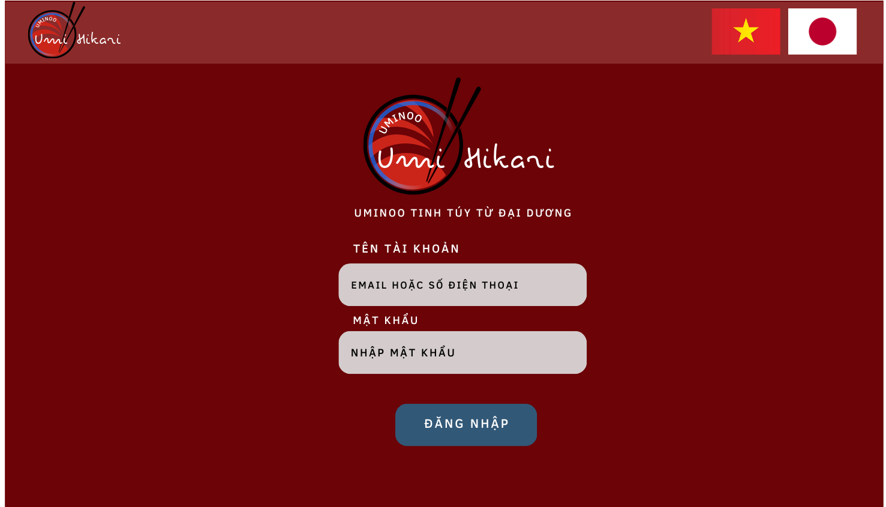
10.4. Interface Admin – Login

10.5. Admin – Cashier (POS) Interface
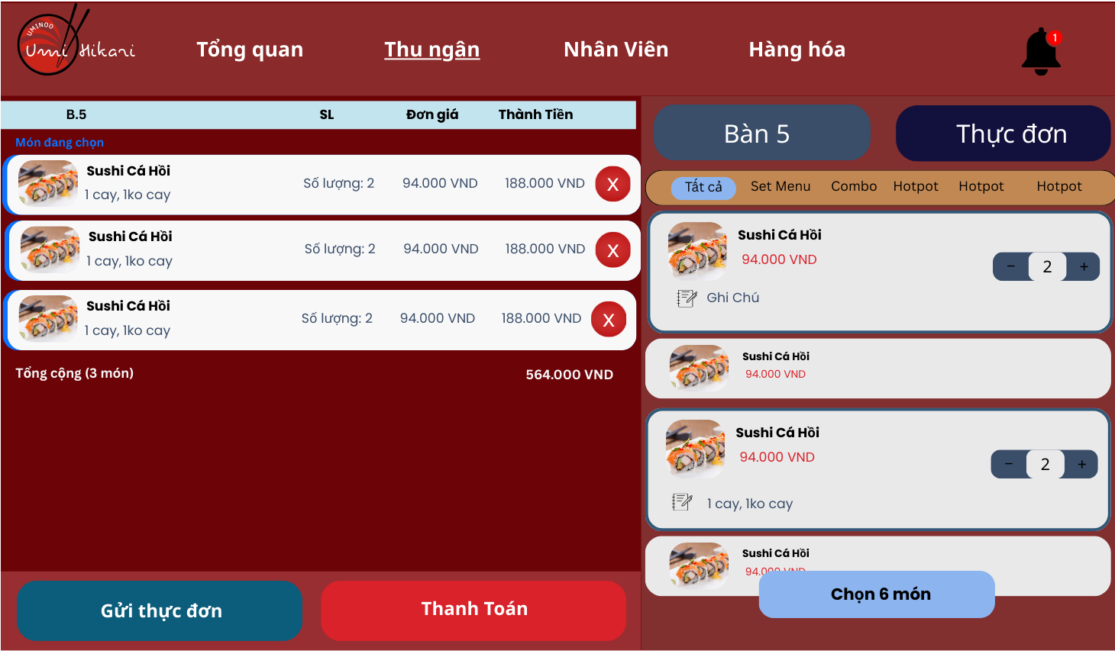
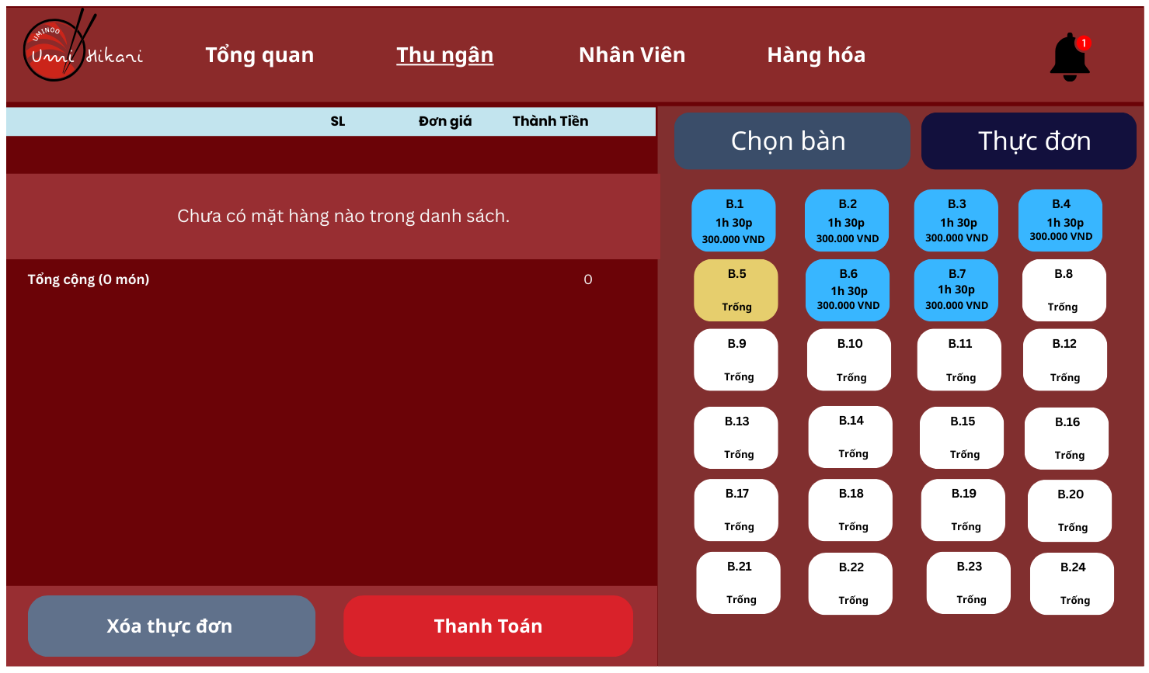

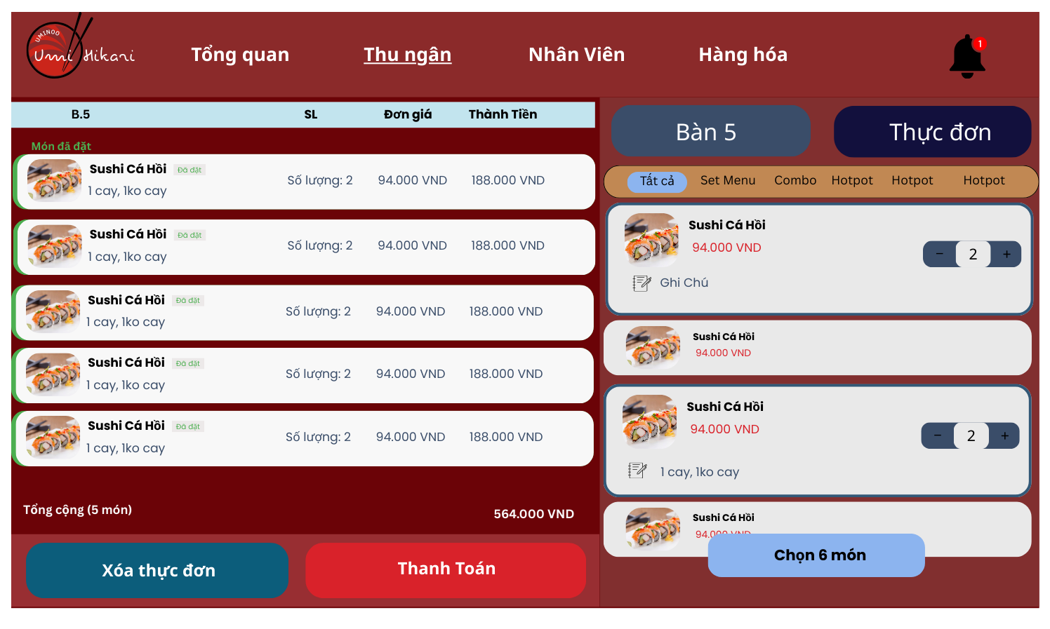

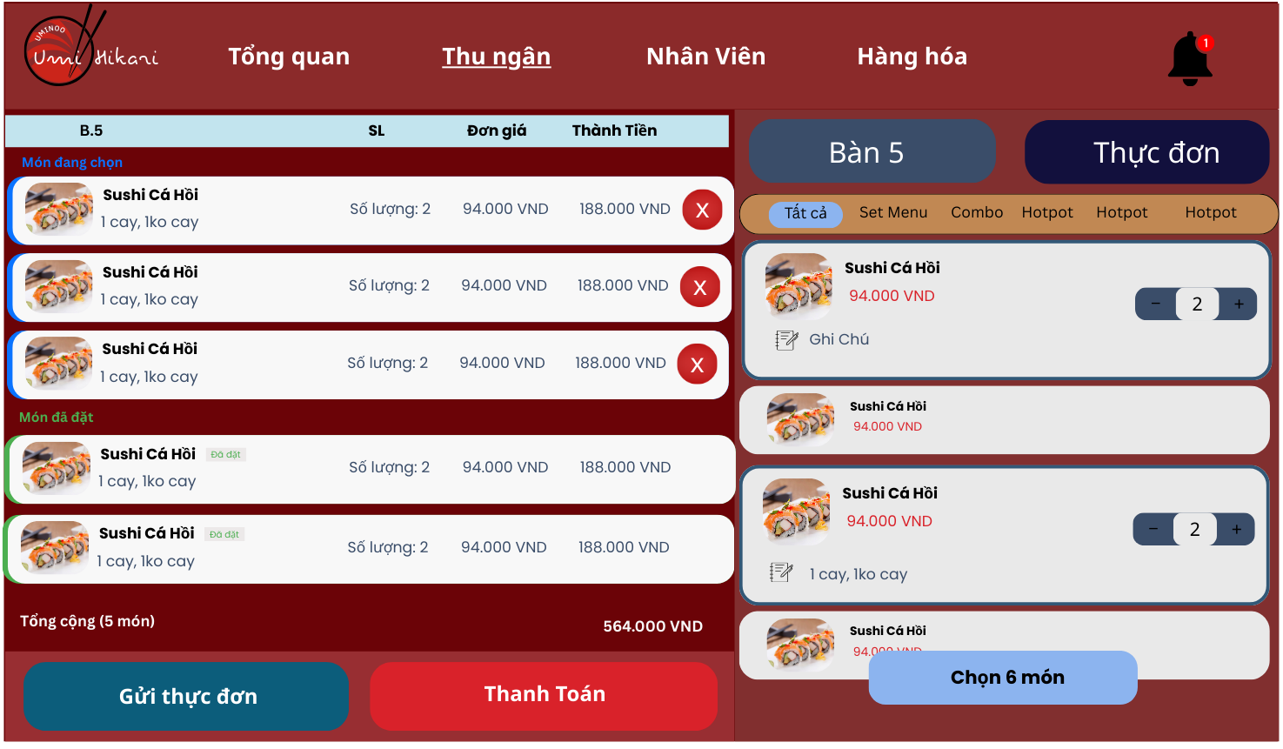

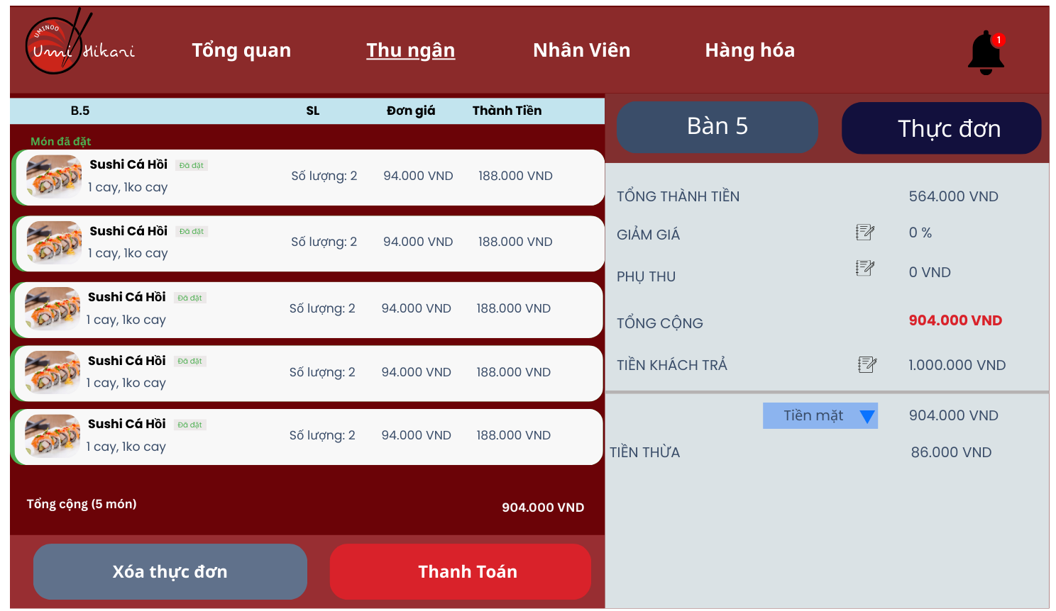

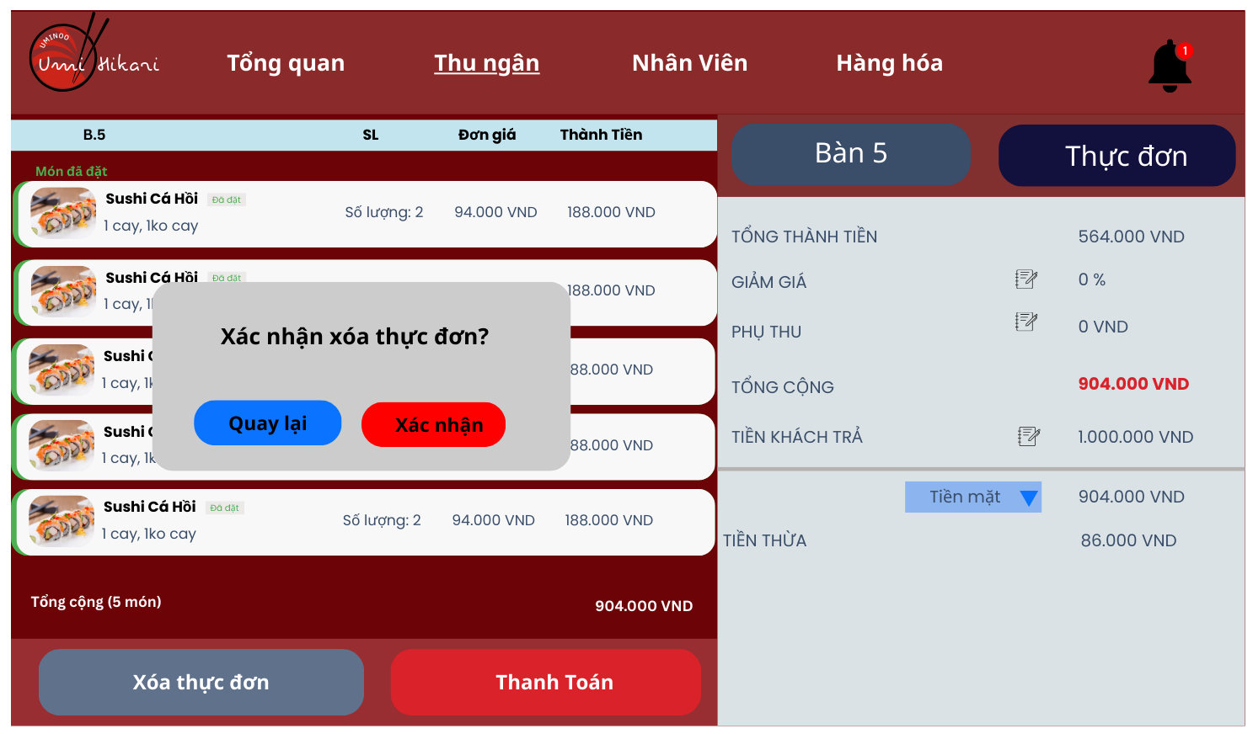

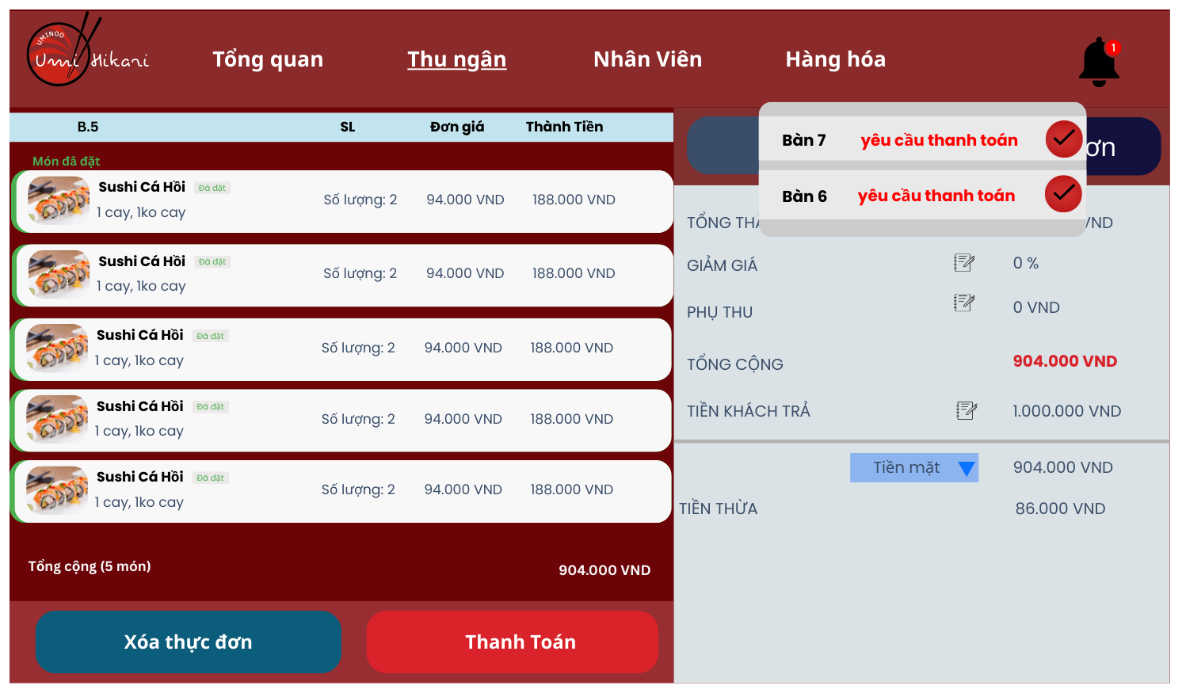

10.6. Staff Management Interface
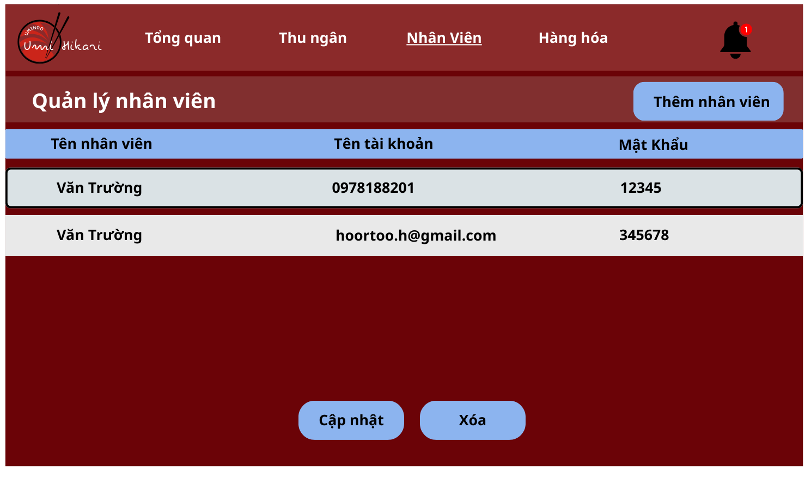

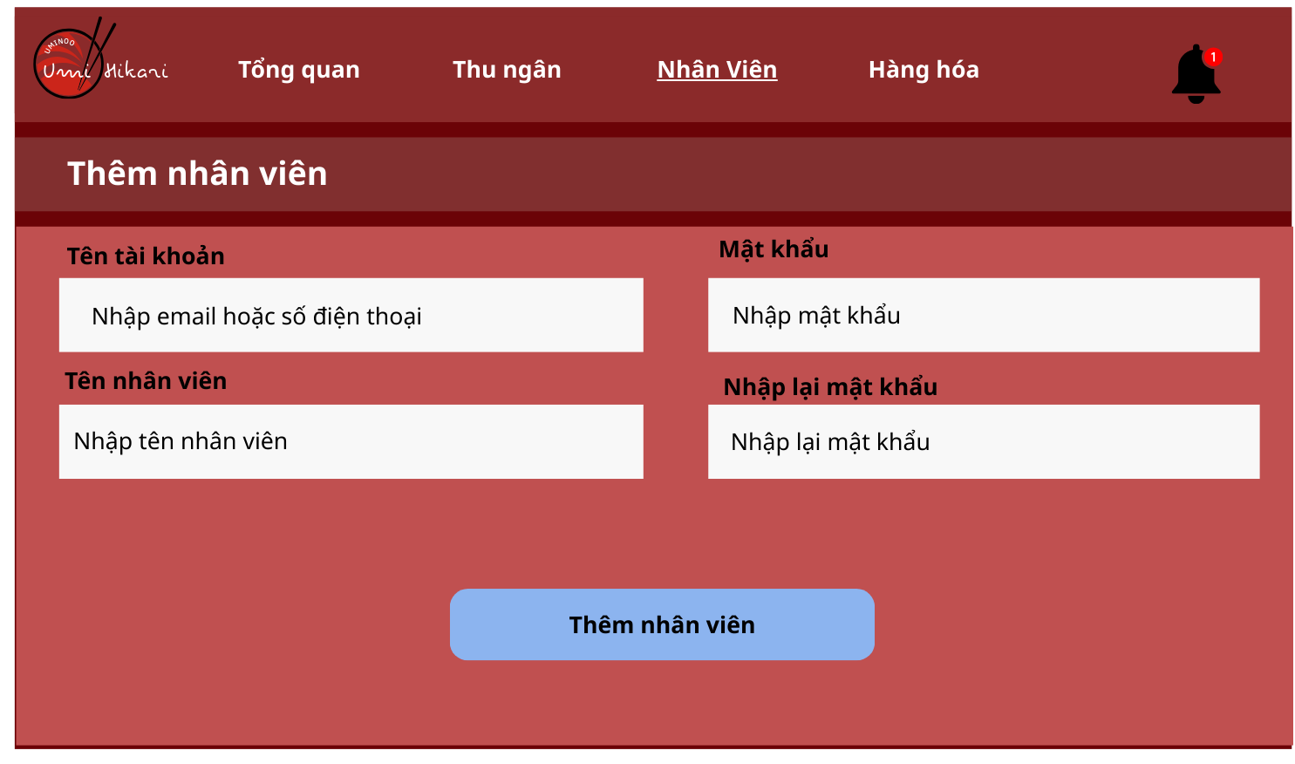

10.6. Menu Management Interface
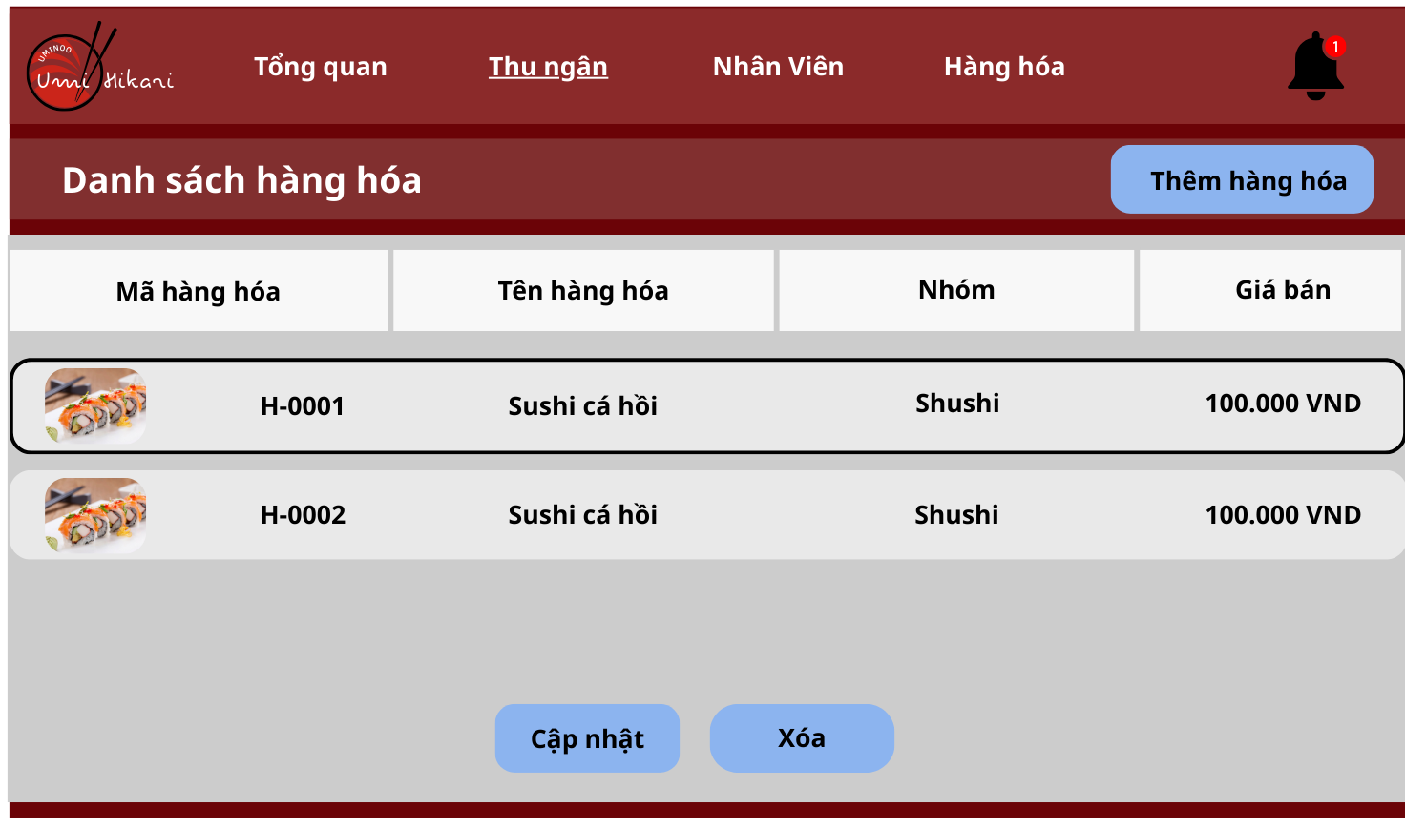

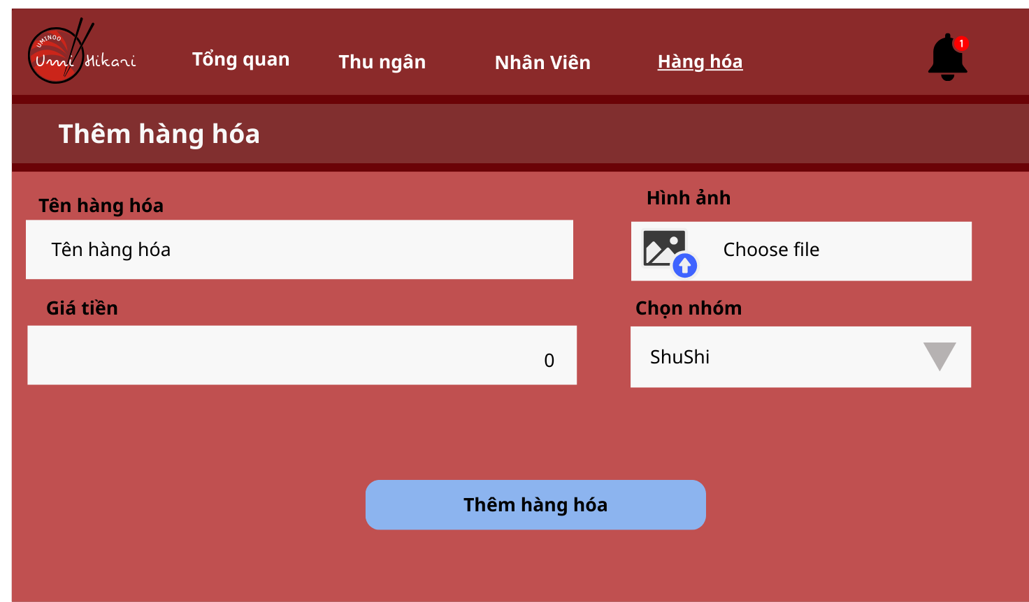

10.7. Dashboard Interface
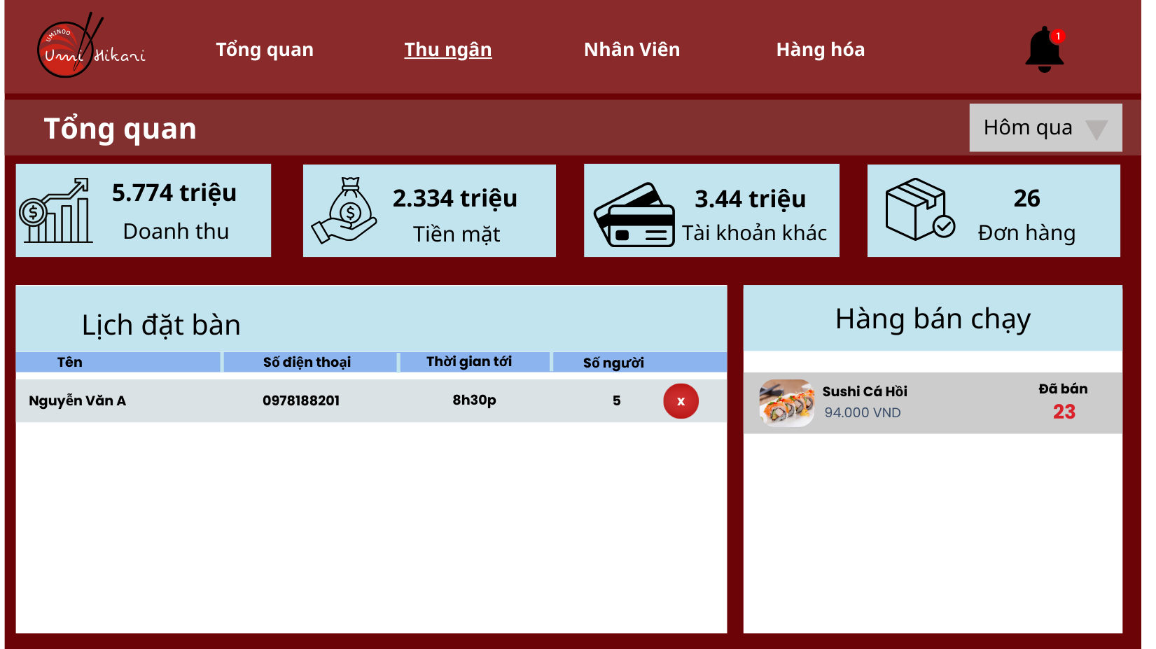

11. APPENDIX
11.1. Glossary
Term | Definition
Order | A list of food and beverage items selected by the customer.
Check-in | The action of a customer occupying a table (triggered by scanning the QR code).
Check-out | The process of completing payment and vacating the table.
Capacity | The total number of available seats in the restaurant (Seating Capacity).
Notes (Special Requests) | Customer's specific requirements for a dish (e.g., less spicy, no onions, allergies).
Surcharge | Additional fees applied to the final bill (e.g., service charge, holiday surcharge).

11.2. References
- IEEE Std 830-1998 (SRS Standards).
- ISO/IEC 25010:2011 - Systems and software Quality Requirements and Evaluation.
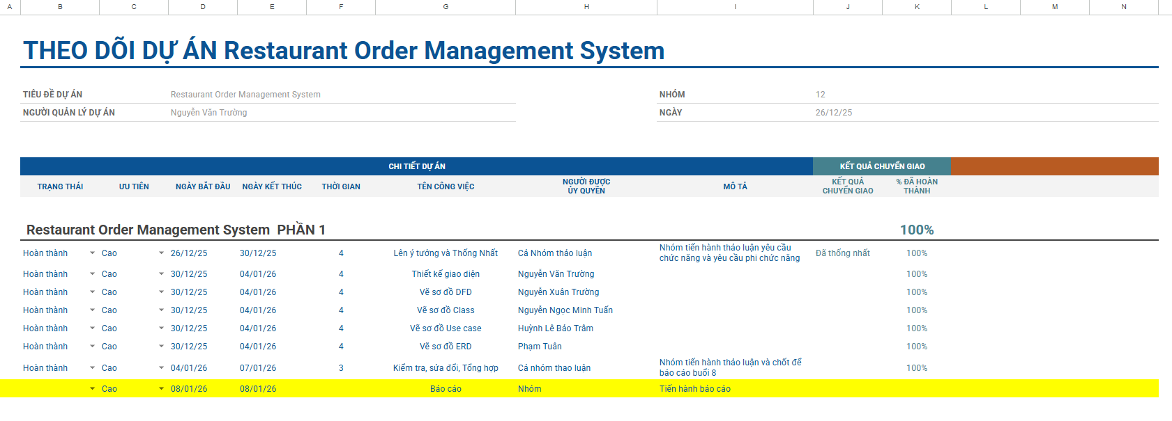
Link: Theo dõi dự án Công Nghệ Phần Mềm - Google Trang tính

